**Part A**



1. x = 0 + 1*1 + 2*2 + 3*3 = 14
   1. x is initialized to 0, then for i=1,2,3: x += i*i
   2. s is just a temporary variable to store i*i

**Part B**



x = 0 + 1*1 + 2*2 + 3*3 + 4*4 + 5*5

x = 0 + 1 + 4 + 9 + 16 + 25

x = 55

**Part C**

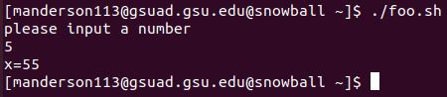

**Part D**

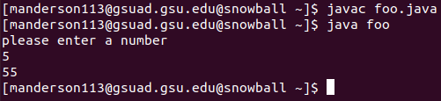

import java.util.Scanner;

class class foo {

public static void main(String[] args) {

int x = 0;

int i = 1;

System.out.println("please enter a number");

Scanner console = new Scanner(System.in);

int num = console.nextInt();

console.close();

while (i <= num) {

int s = i * i;

x = s + x;

i = i + 1;

}

System.out.println(x);

}

}

**Part E**



1. hello



1. .



#include <stdio.h>

int main(void)

{

printf("My name is Michael Anderson\n");

return 0;

}